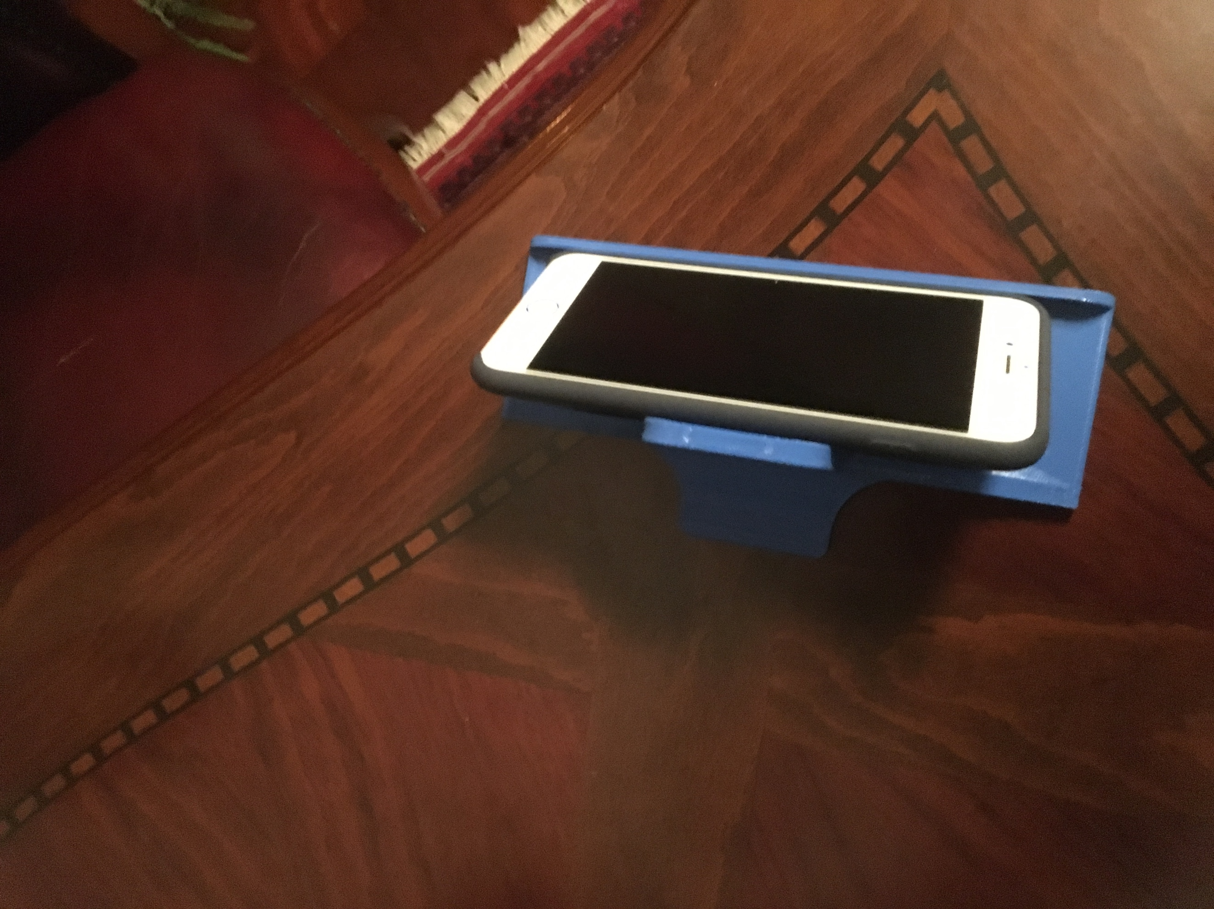Phone Stand

While designing this I had no idea how to design something in 3D because it was my first at the club. Though with help and logic I managed to design this gadget. At home when I am alone and eating something I always watch films or videos. But I put my phone into a nut cracker and make it visible. Unfortunately nut cracker covers some of the screen and it is not practical. So I decided to design something for my phone. I first made rectangle and extruded it and cut some of it’s parts and rounded a bit in order to make it lighter and cheaper. In this whole situation club members helped me a lot.